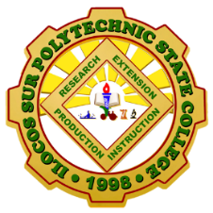
Revised 2018
OSAS Form No.4
Republic of the Philippines
ILOCOS SUR POLYTECHNIC STATE COLLEGE
OFFICE OF STUDENT AFFAIRS AND SERVICES
Main Campus, Sta. Maria 2705, Ilocos Sur
A vibrant and nurturing Polytechnic Service College

LIST OF ELECTED OFFICERS
School Year ___________
_________________________________________________
Name of the College/Unit
________________________________________________
Name of Club/Organization

NAME | POSITION | HOME ADDRESS | TEL. NO

